Tutorial Instructions: Sugar glider face finder

1. Open the TrainAsugargliderDetector.m file in matlab

2. Type the image locations for both positive and negative folders (contain the sugar glider faces)

By editing the following lines in red :

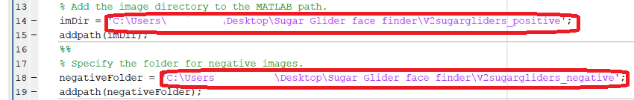

3. In Matlab, go to the **Training image labeller** program and click the "open session" button.

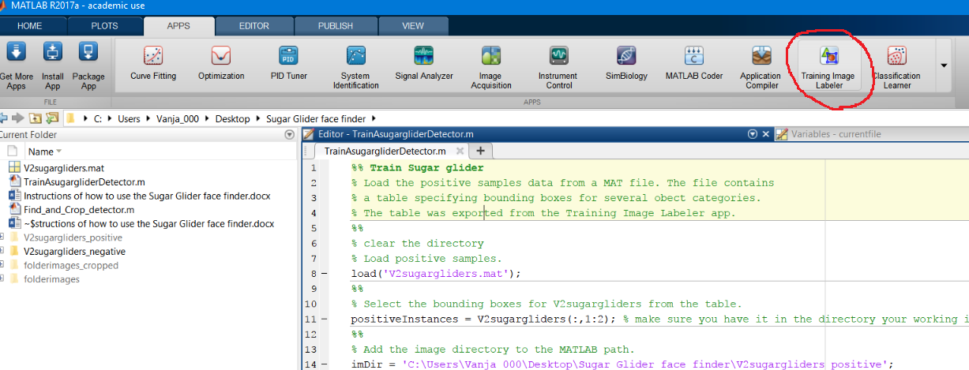

Select the V2sugargliders.mat file and press open. This will load 9 images of sugar gliders

with ROI already selected. Do not change any of the selected ROI’s.

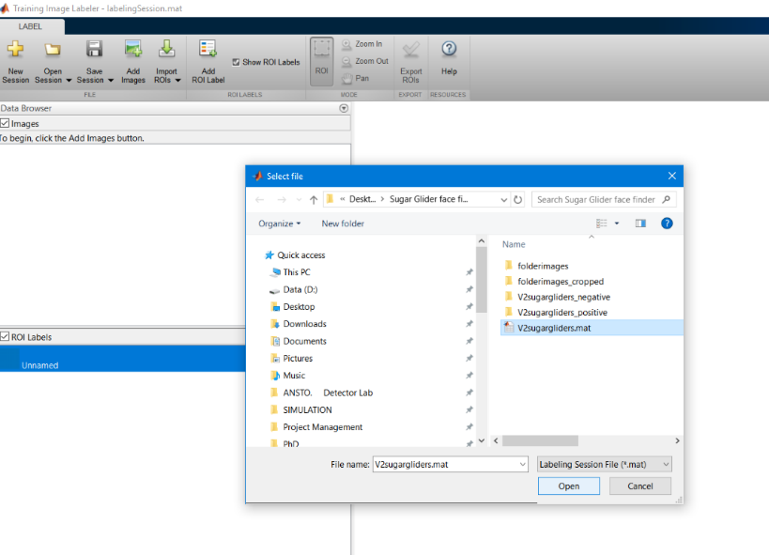

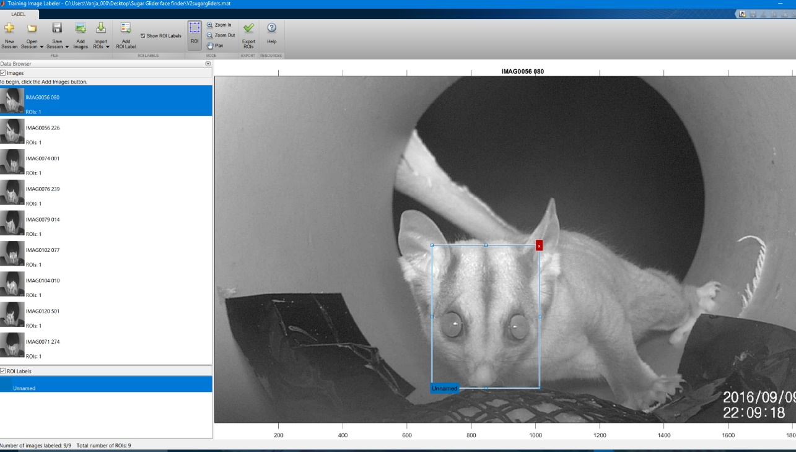

Now press the green tick button at the top toolbar called "Export ROIs". Leave the format as a table and rename it to V2sugargliders. What this does is exports a table into the current working matlab directory, which is needed to run the TrainAsugargliderDetector.m.

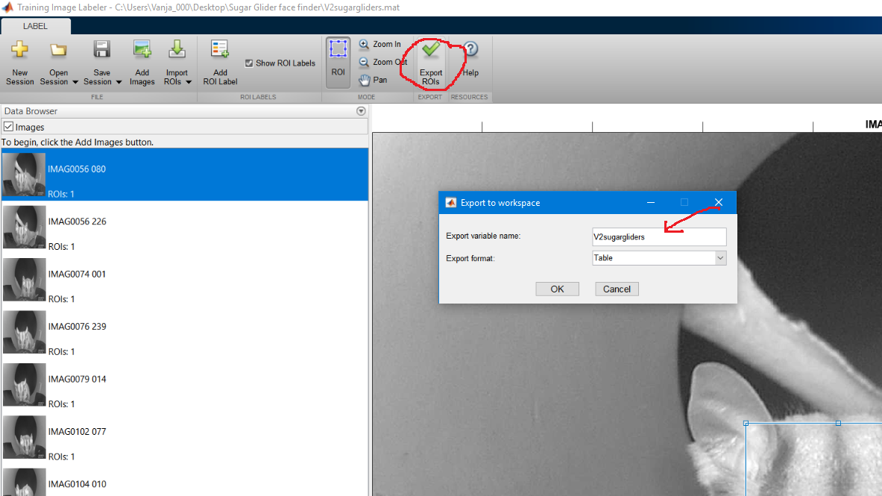

Check that the V2sugargliders table is in the current workspace.

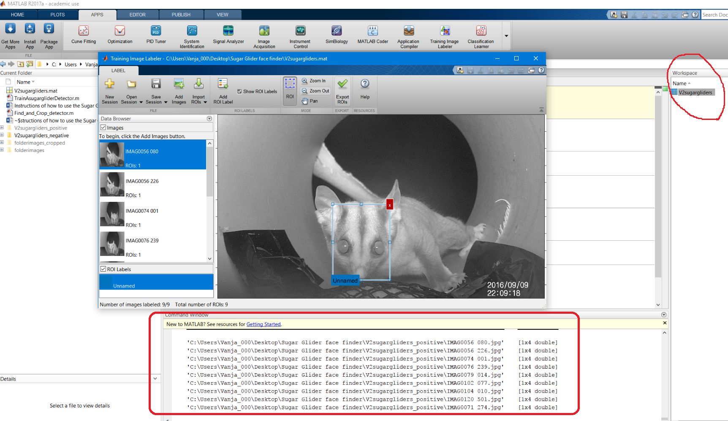

4. Now you can press the editor button to run the code.

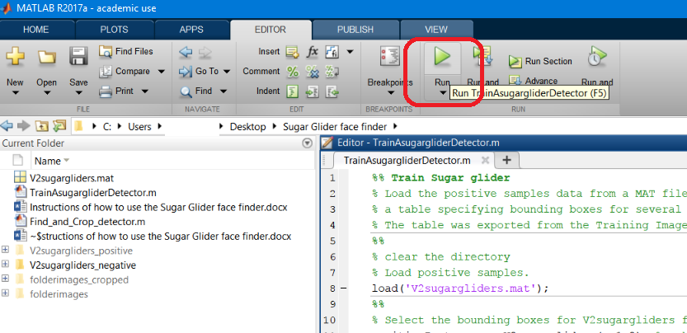

It should return something like this to your screen:

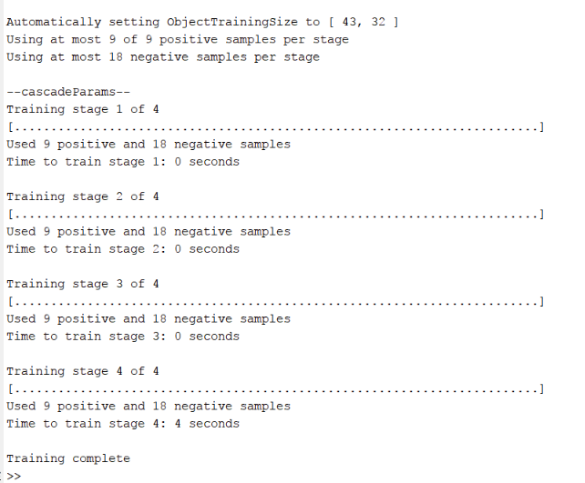

Check that the above is displayed on your computer. You have just trained the

Cascade detector.

5. Now you can open the "Find_and_Crop_detector.m" in Matlab.

Change the lines that are circled in red to the actual location of the files on your computer.

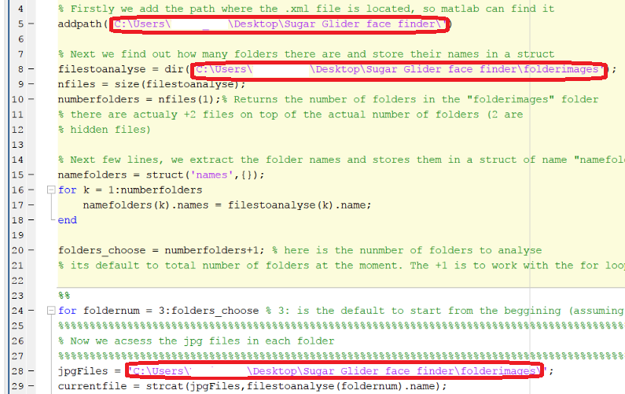



6. Run the code. Now when you go to the cropped images folder you should see that 8 images were identified and cropped, like in the image below.



That’s it! For further implementation for your unique application, please read the guides and documentation available on the MATLAB website that go into detail about training a cascade object detector. <http://au.mathworks.com/help/vision/ug/train-a-cascade-object-detector.html>

For further questions & feedback, please contact Vanja Gracanin; [vg724@uowmail.edu.au](mailto:vg724@uowmail.edu.au)